

**Project Report**

**On­­**

**“Car Rental Booking System”**

**Team Members:**

* **Rafay Hussain (student1310797)**
* **Syed Huzaifa Ali (student1303453)**
* **Bilawal (student1305949)**

**Center:**

**ACE-PK-HYDERABAD-2**

SUPERVISOR

***Syed Huzaifa Ali***

**CERTEFICATE**

**This is to certify that**

Rafay Hussain

Syed Huzaifa Ali

Bilawal

**Has Successfully Design and Developed**

**“Car Rental Booking System”**

**Submitted By:**

**Center Academic Head**

**ACE-Hyderabad-2**

|  |  |  |
| --- | --- | --- |
| **Serial No** | **Topic** | **Page No** |
| 01 | Introduction | 04 |
| 02 | Home | 05 |
| 03 | Admin Panel | 06 |
| 04 | General Setting | 07 |
| 05 | Contact Setting | 08 |
| 06 | Vehicle List | 09 |
| 07 | Booking List | 10 |
| 08 | Booking Details | 11 |
| 09 | Manage Testimonials | 12 |
| 10 | Sign in | 13 |
| 11 | Sign up | 14 |
| 12 | Profile Upgrade | 15 |
| 13 | Booking History | 16 |
| 14 | Post Testimonial | 17 |
| 15 | Software | 18 |

**Content**

## *Introduction: –*

Currently FAST CARS is handling customer queries and booking either through telephone or walkins. They are not utilizing the vehicles to optimum bookings. They are looking for better booking system and want to increase their reach to the customers

***Proposed Solution:*** –

They have planned to introduce website for booking Cars for Rentals.

It is a system design especially for large, premium and small car rental business. The car rental system provides complete functionality of listing and booking car.

It enables users to choose and book the car as per their requirements.

***Home:***

Home page is a main page. When this website will be run you will be see this page. In this page you see a slider, side section and footer on the bottom.

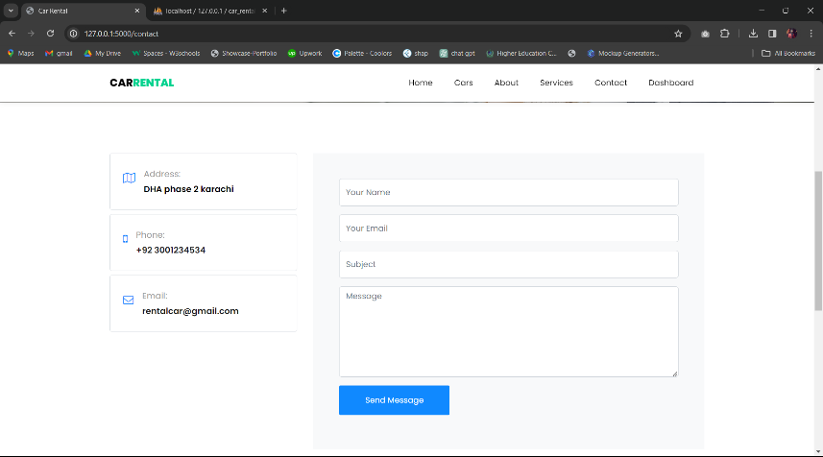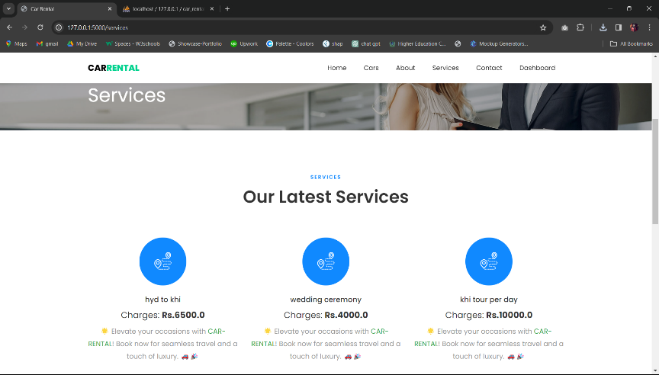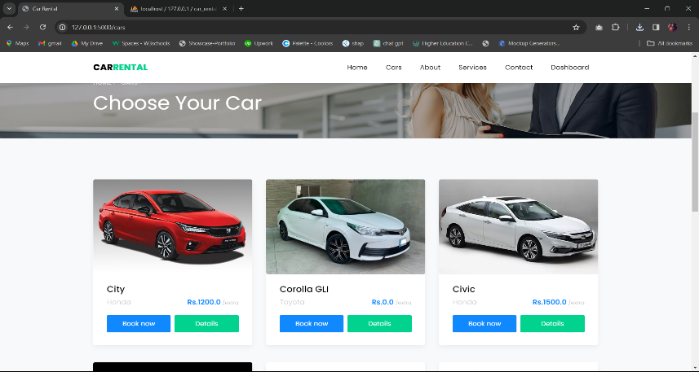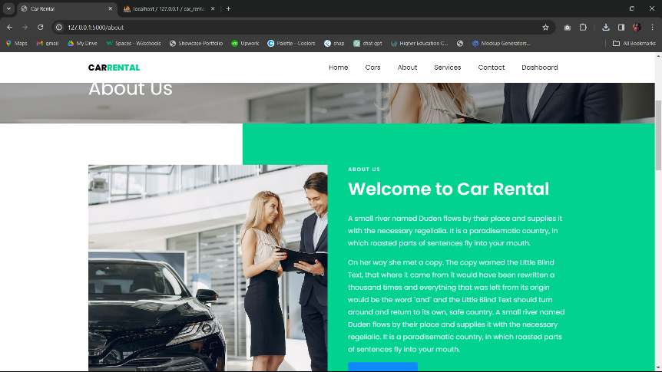

***Admin Panel:***

In this page you will be see Admin Panel. If admin sign in Admin Panel, the dashboard form will open.

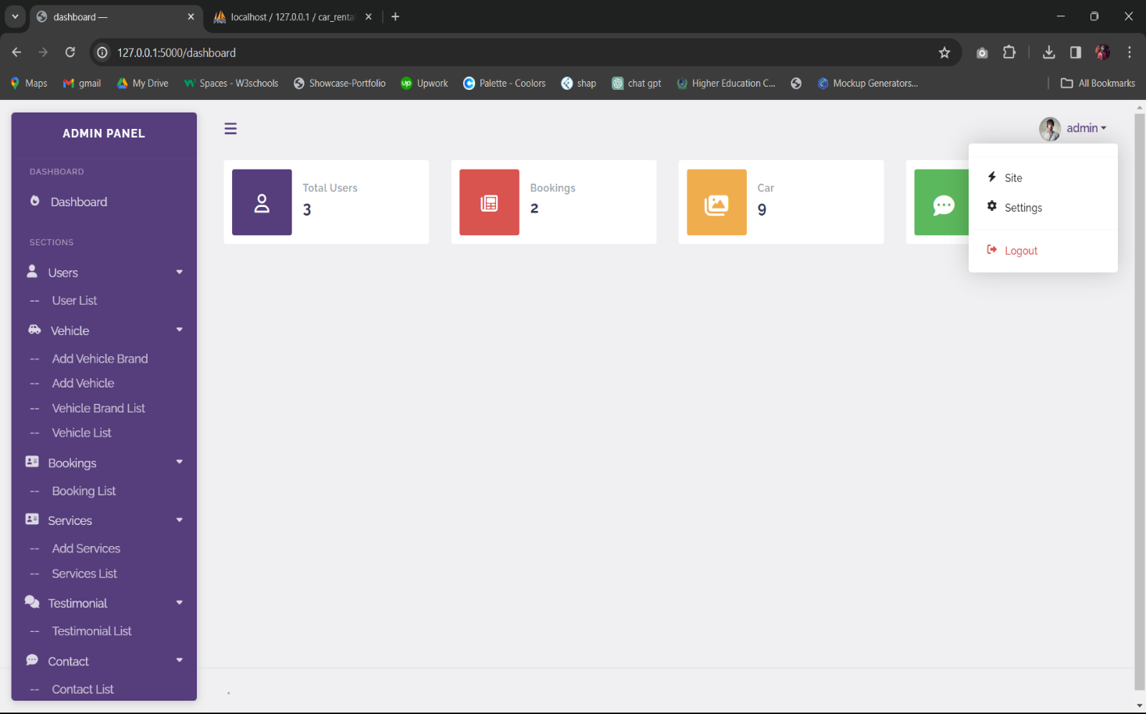***General Setting:***In this page we can update the description of SEO. If the site is undergoing work, we can also turn on maintenance mode.

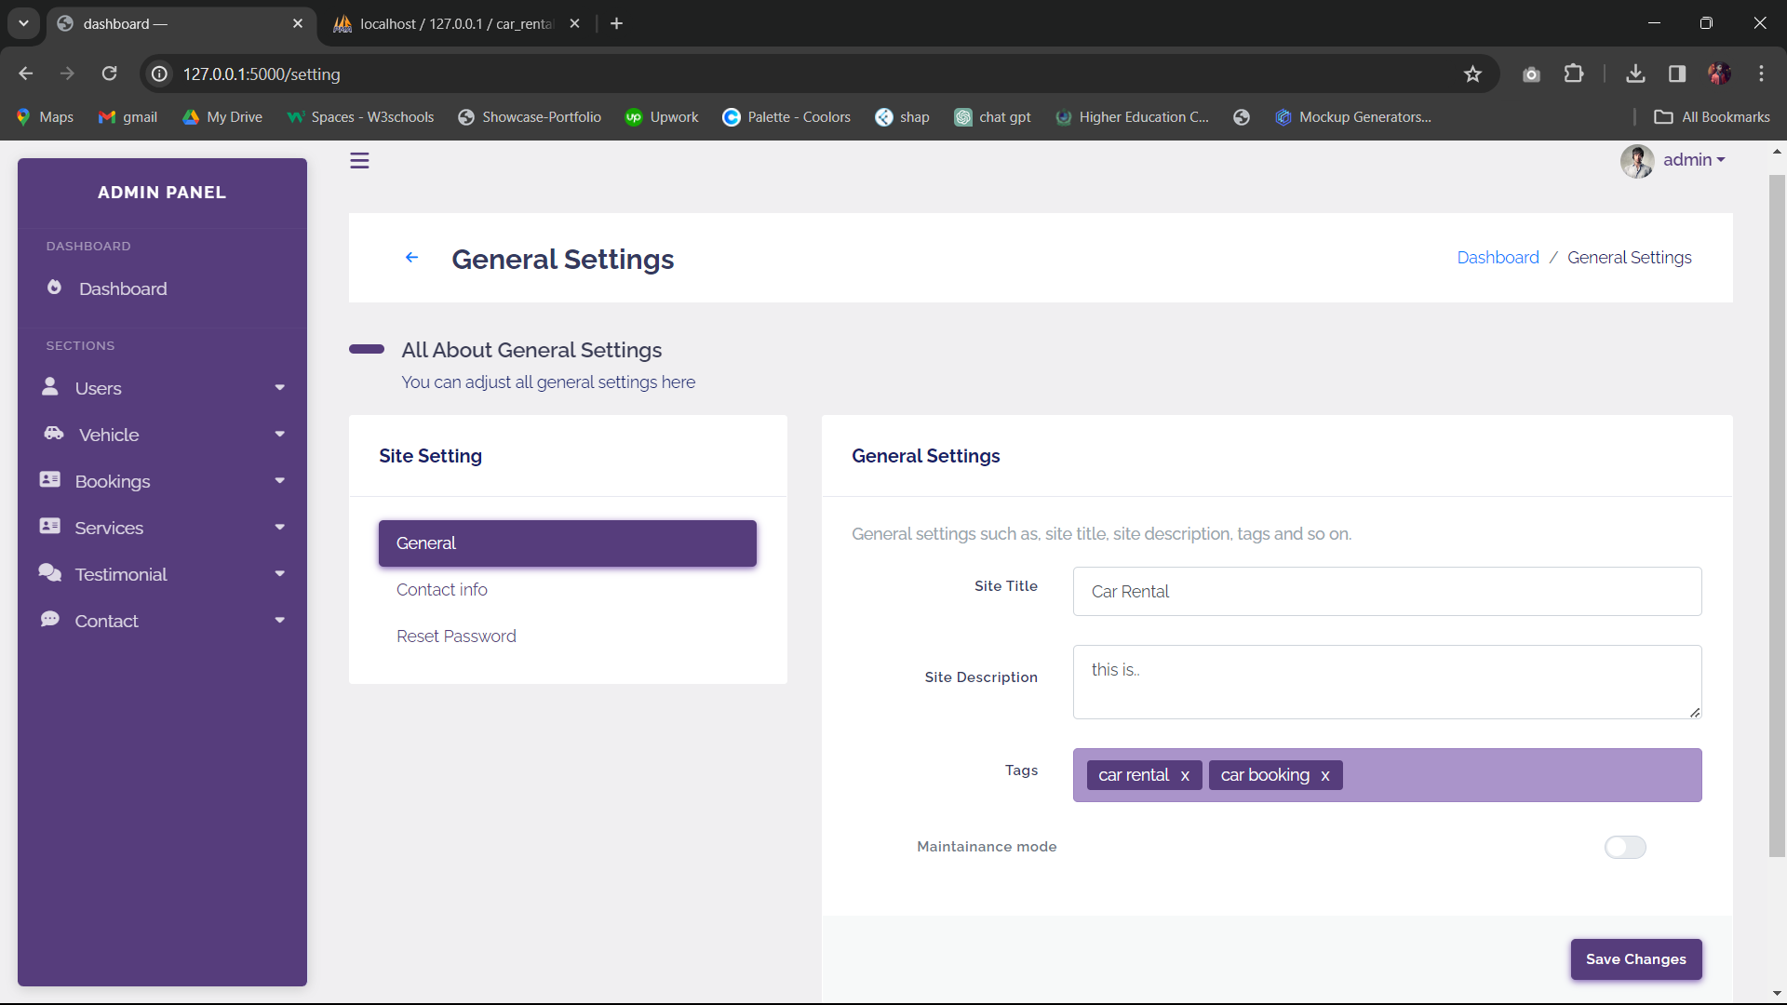

***Contact Setting:***  
Connecting made easy. Explore our user-friendly contact settings for hassle-free communication. Your convenience, our priority.

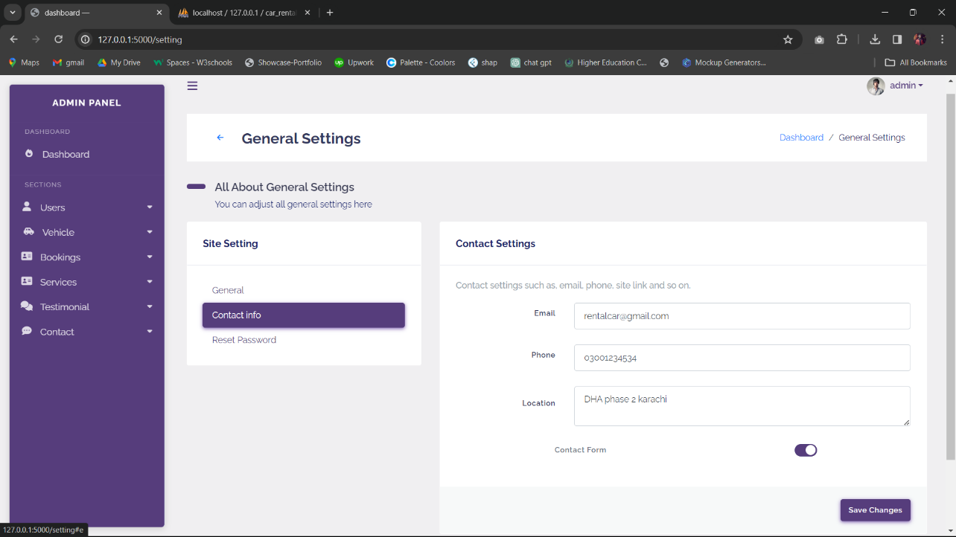

***Vehicle List:***

Stay in the driver's seat of your adventures! Check out your personalized vehicle list for a quick glance at your past and upcoming rides. Your journey, your fleet

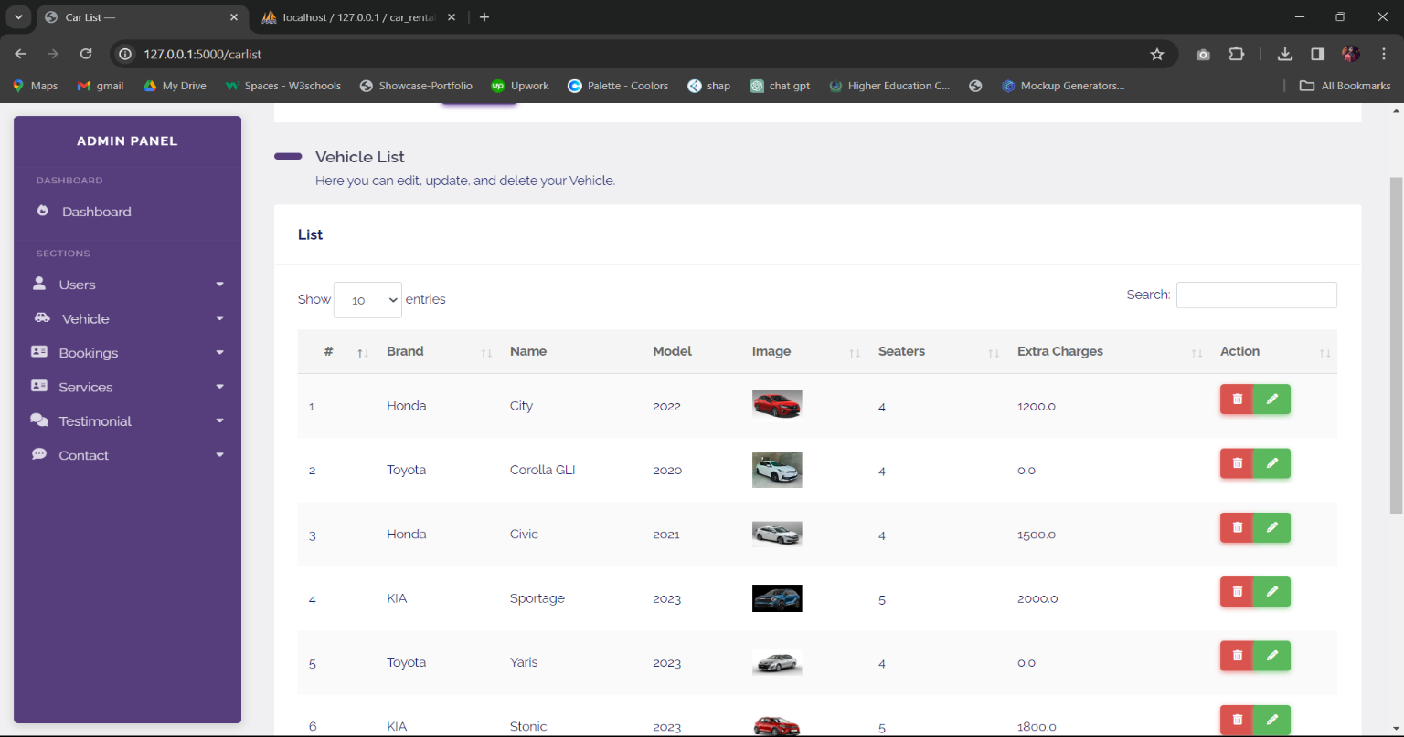***Booking List:***

Hit the road with confidence! Access your curated car booking list for a quick overview of your past and upcoming drives. Your journey, your ride.

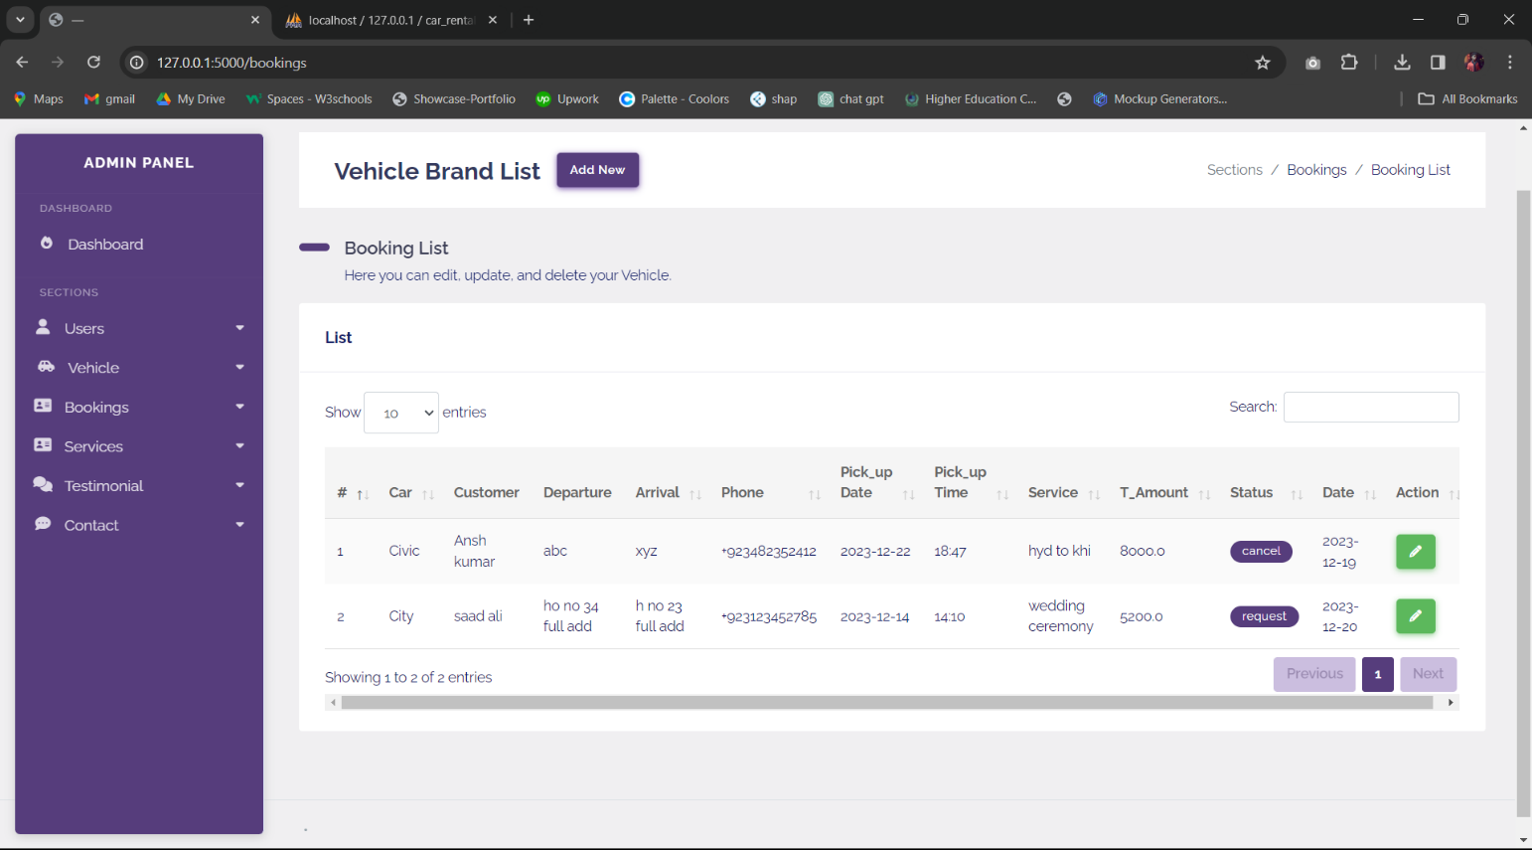

***Booking Details:***

Effortlessly manage reservations with a seamless view and update experience. Stay in control of your booking details with ease.

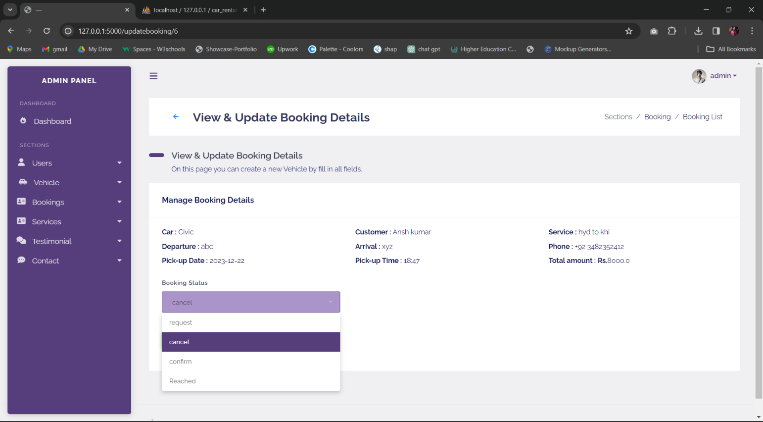

***Manage Testimonial:***

Empower your brand with impactful testimonials. Learn how to effectively manage and showcase customer feedback to build trust and credibility.

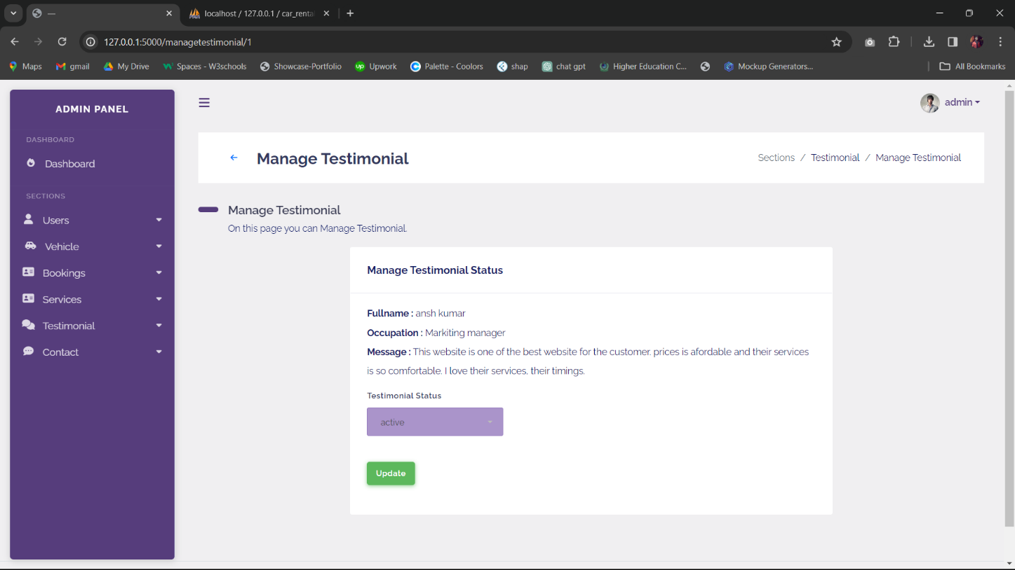

***Sign In:***

Welcome back! Sign in to your account for a seamless and personalized experience. Your next adventure is just a click away.

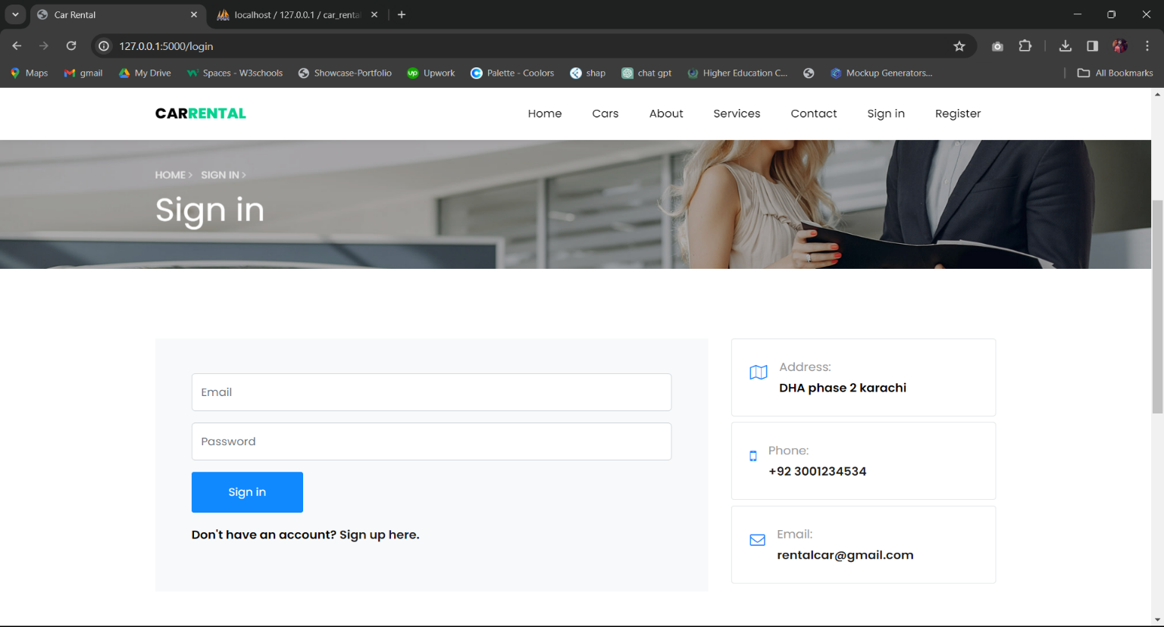

***Sign up:***

Embark on a new adventure! Sign up now to join our community and unlock a world of exciting opportunities. Your journey awaits.

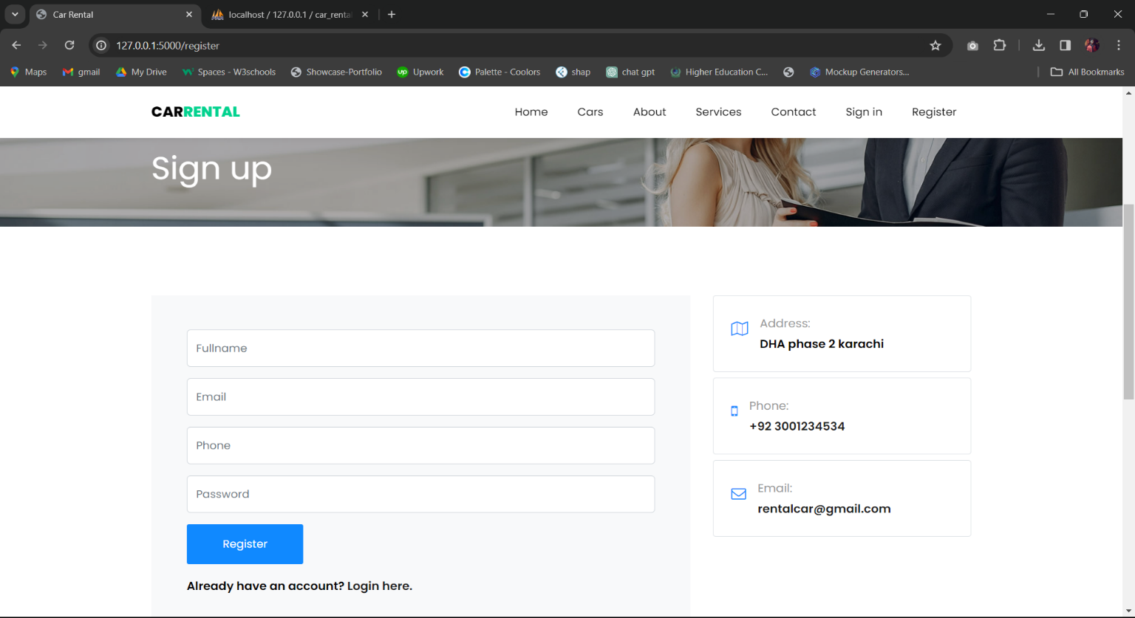

***Profile Update:***

Where a customer can update their profile, take bookings, testimonial post, reset their password.

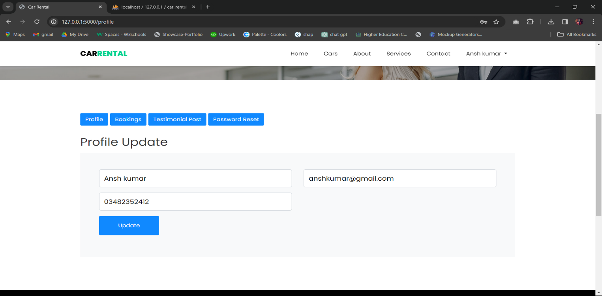

***Booking History:***

Track your journey through time with ease. Dive into your personalized booking history for a seamless review of past adventures. Your travel story, all in one place.

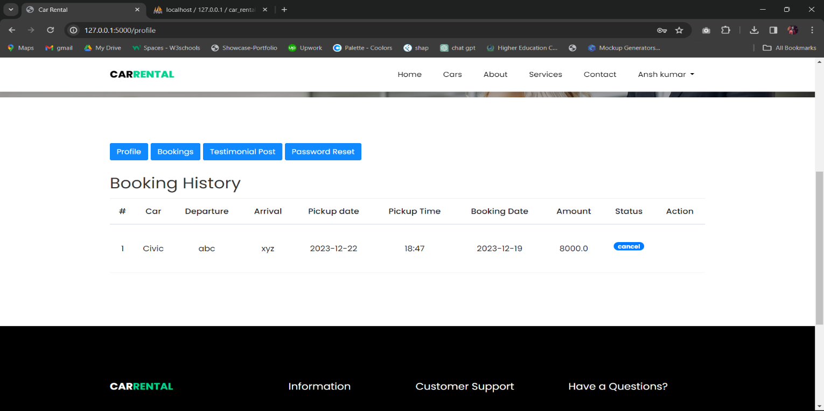

***Post Testimonial:***

Thrilled to share the joy of our valued customers! Hear what they have to say about their experiences with us. Real stories, real satisfaction.

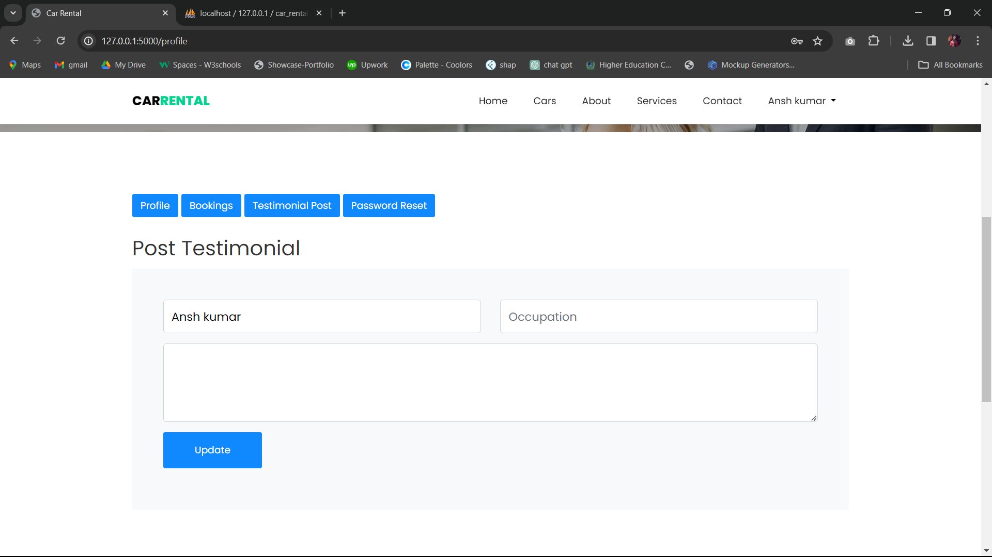

***Software***

* HTML 5
* CSS 3
* BOOTSTRAP
* My SQL
* PYTHON